**WORK FROM 12 - 1**

Register Number: 1740256

**Date:** 09/3/2018

--------------------------------------------------------------------------------------------

**Question 1**

An expert sharpshooter misses a target 10 percent of the time. Identify the probability that she misses the target for the 22nd time in her 10th shot. Identify the probability that her 22nd miss comes no later than her 1010th shot

**Answer**

**NOT POSSIBLE – BECAUSE THERE CANNOT BE 22 MISSES IN HER 10TH SHOT – Assuming it is her 2nd time, then we can figure out something.**

**--------------------------------------------------------------------------------------------------------------------------------------**

**Question 2**

A representative from the National Football League's Marketing Division randomly selects people on a random street in Kansas City, Kansas until he finds a person who attended the last home football game. Let *p*, the probability that he succeeds in finding such a person, equal 0.20. And, let *X* denote the number of people he selects until he finds his first success. Obtain the probability that the marketing representative must select 4 people before he finds one who attended the last home football game.

**Answer**

**The above question follows Geometric distribution.**

**X = 4**

**P(X) = p*q^x**

**P = 0.2; q = 0.8**

**Therefore, p(x) = (0.2)*(0.8)^4**

**P(x) = 0.08**

**--------------------------------------------------------------------------------------------------------------------------------------**

**Question 3**

A small voting district has 101 female voters and 95 male voters. A random sample of 10 voters is drawn. Obtain the probability exactly 7 of the voters will be female.

**Answer**

**The above question follows Hyper-Geometric Distribution.**

**((101 C 7) * (95 C 3))/196 C 10 = 0.13**

**--------------------------------------------------------------------------------------------------------------------------------------**

**Question 4**

Derive the mode of Poisson distribution.

**Answer**

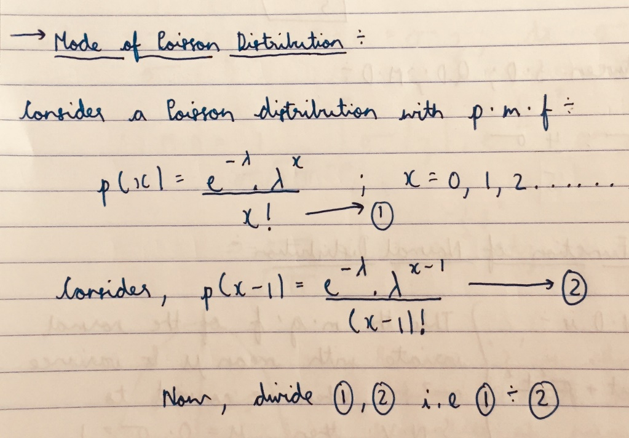

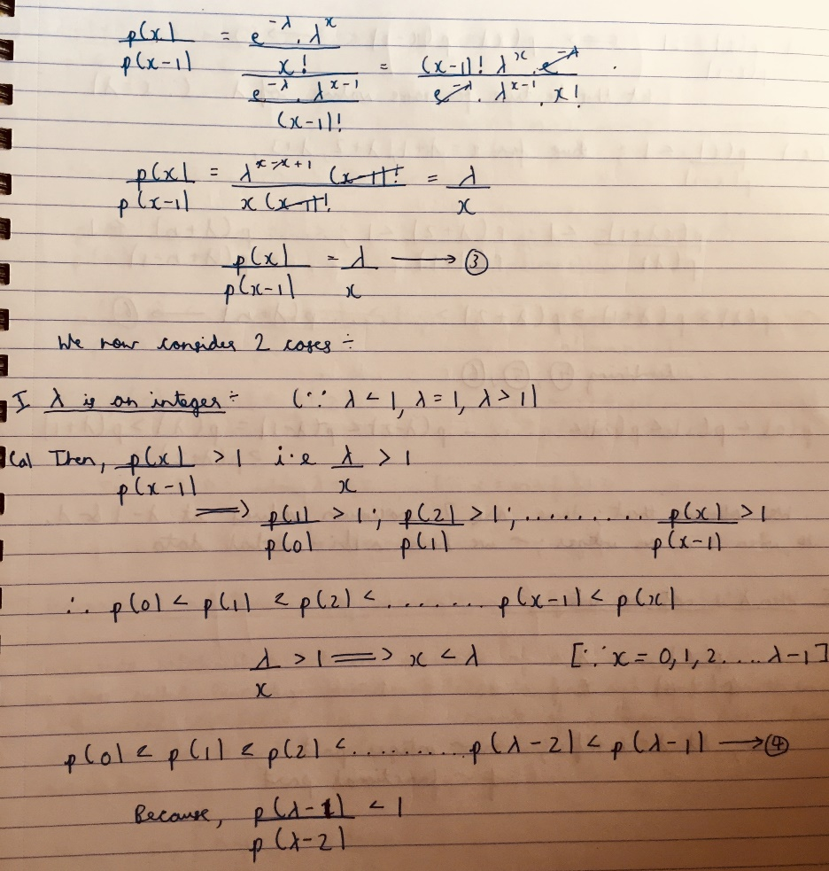

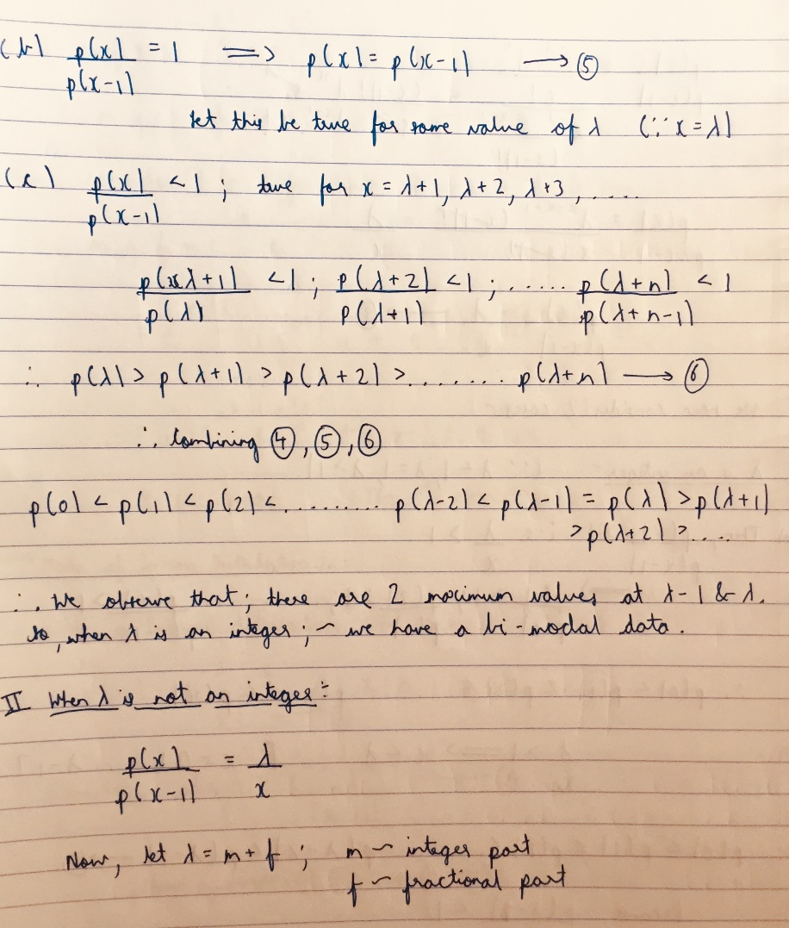

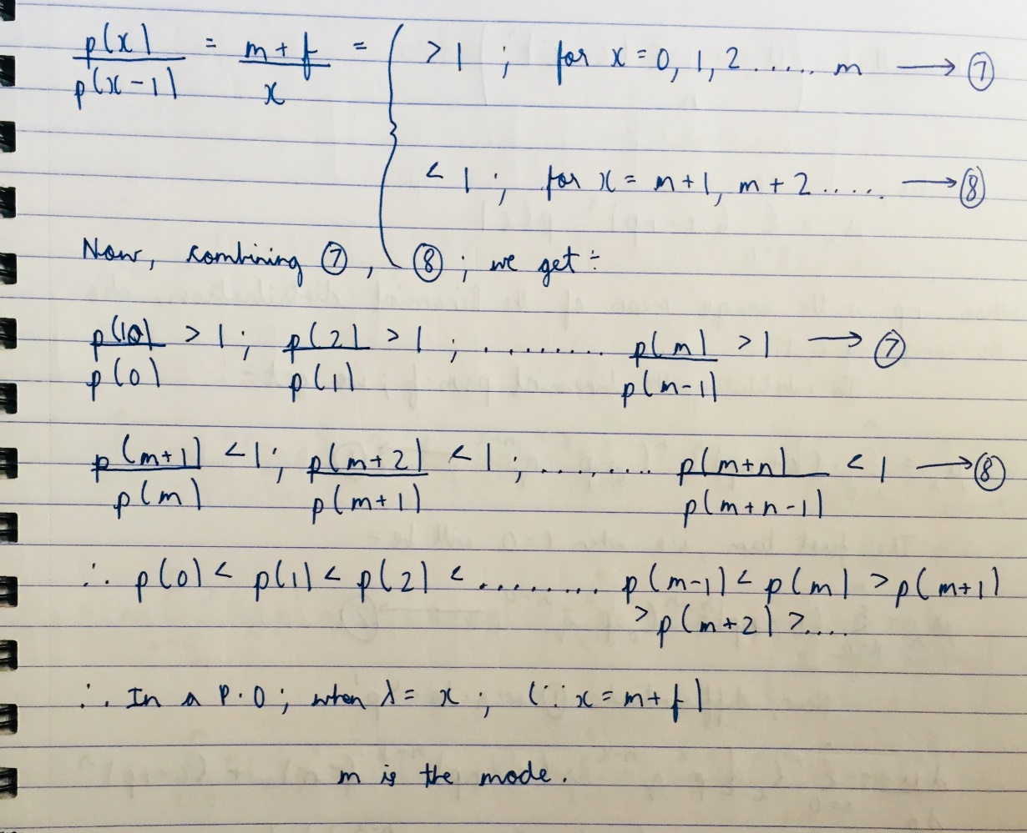

**--------------------------------------------------------------------------------------------------------------------------------------**

**THE END**

**--------------------------------------------------------------------------------------------------------------------------------------**